**NETWORKING FUNDAMENTALS WEEK 8: ROCKING YOUR NETWORK**

**PHASE 1:**

* 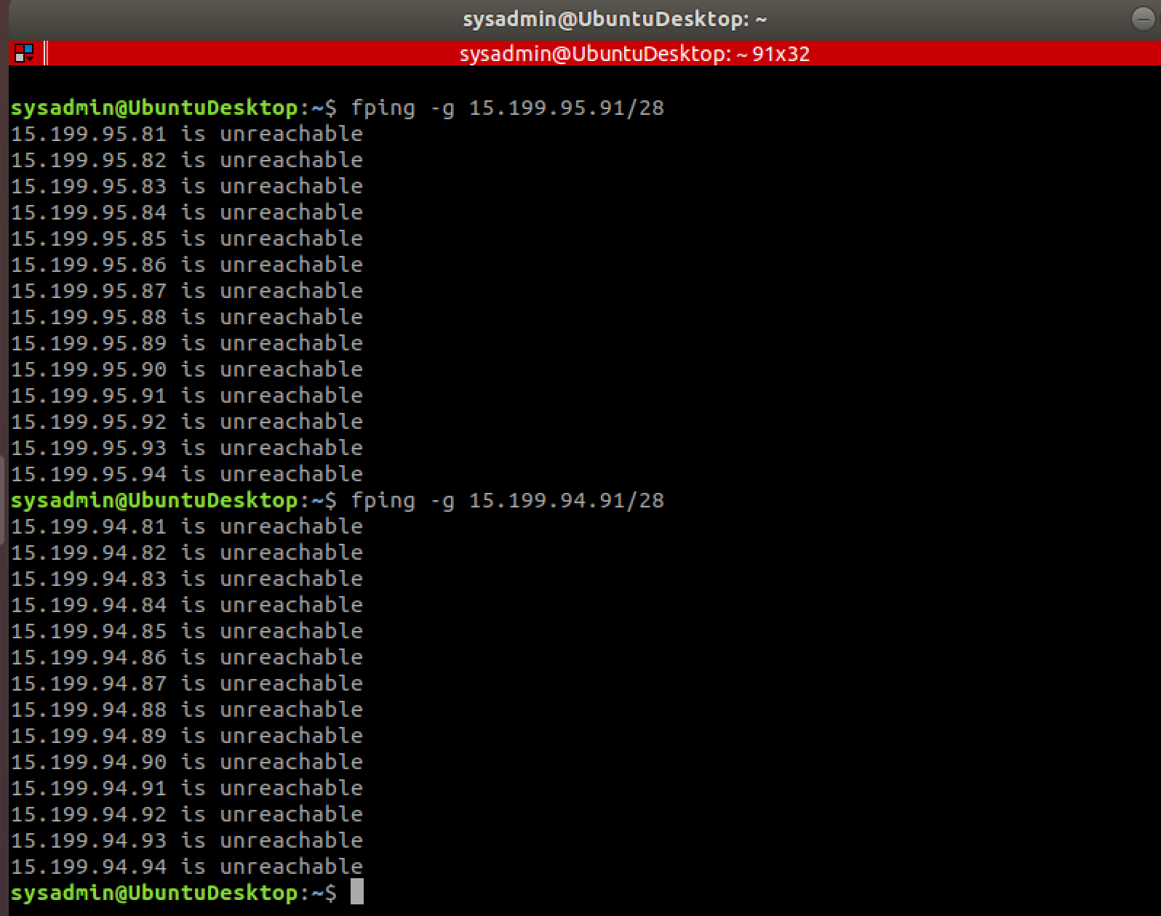

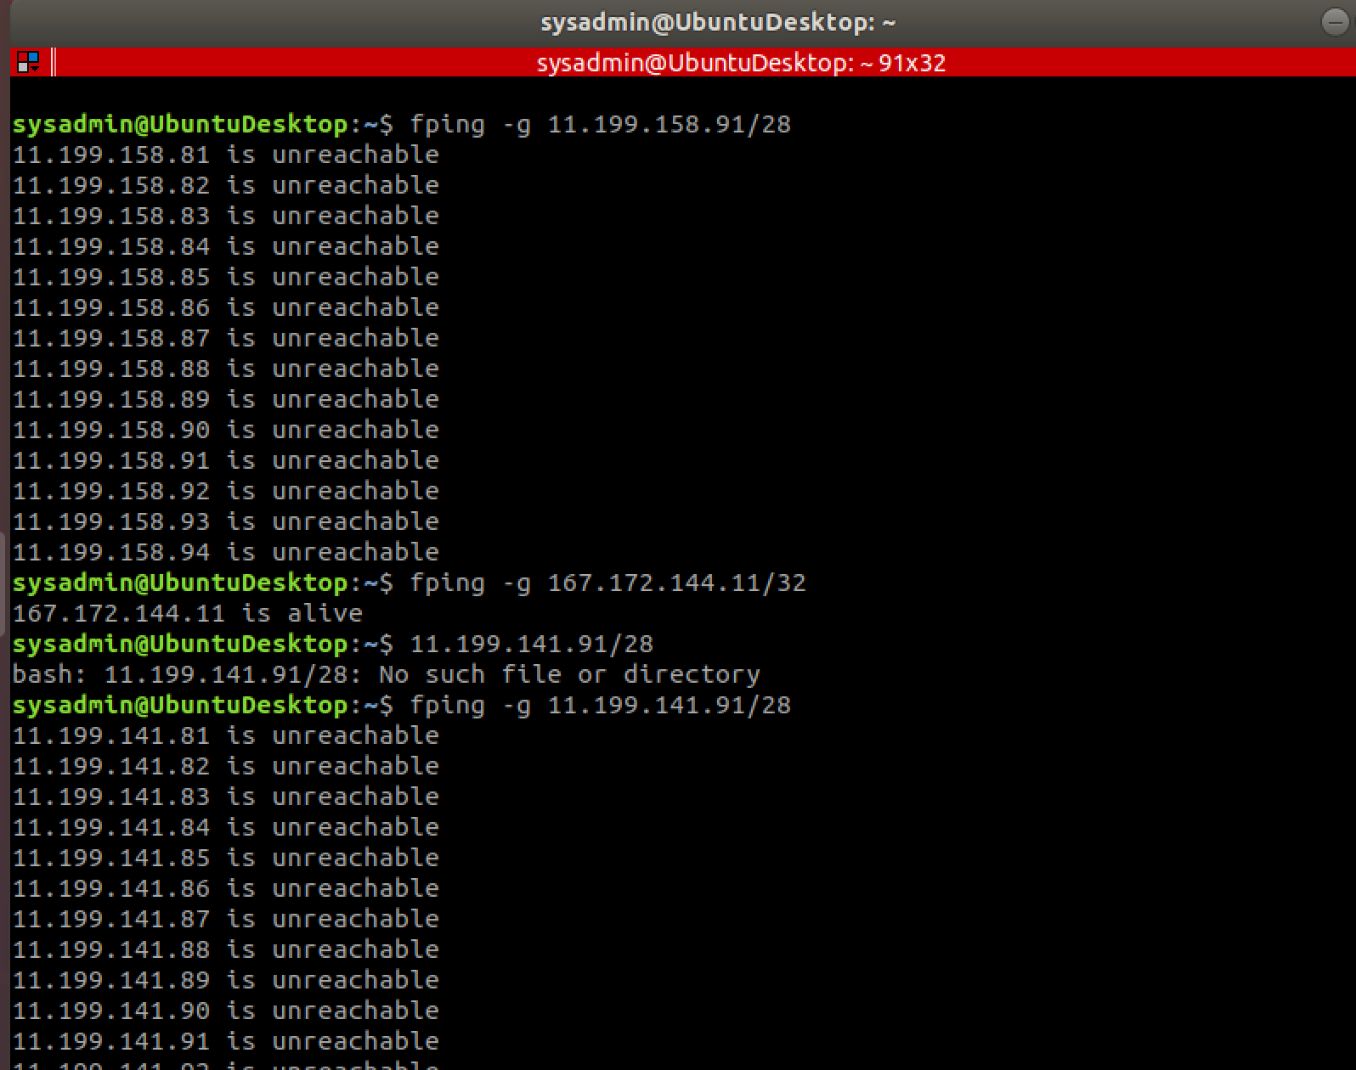

* **Summary of finding: Found that IP host 167.172.144.11 is still alive.**
* **OSI Layer: Layer 3 Networking**

**PHASE 2:**

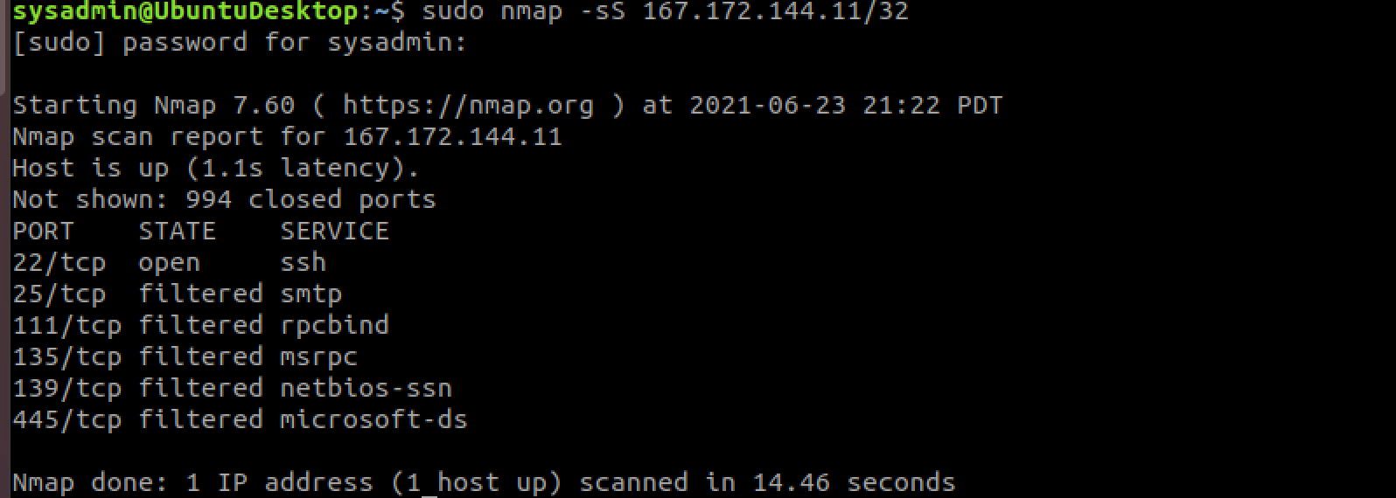

* **Summary of finding: After running sudo nmap -sS ﻿167.172.144.11/32 port 22 is open and accepting connections.**
* **Network vulnerabilities: Yes, Port 22 is open and domain can be compromised by an attacker.**
* **OSI Layer: Layer 4 Transport**
* **PHASE 3:** 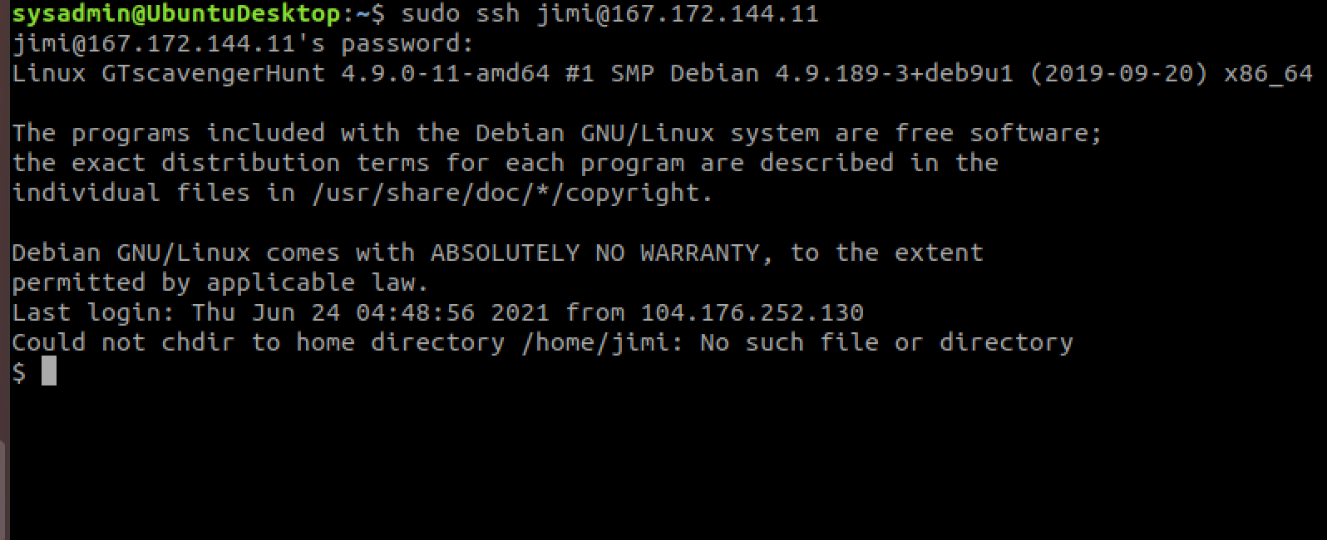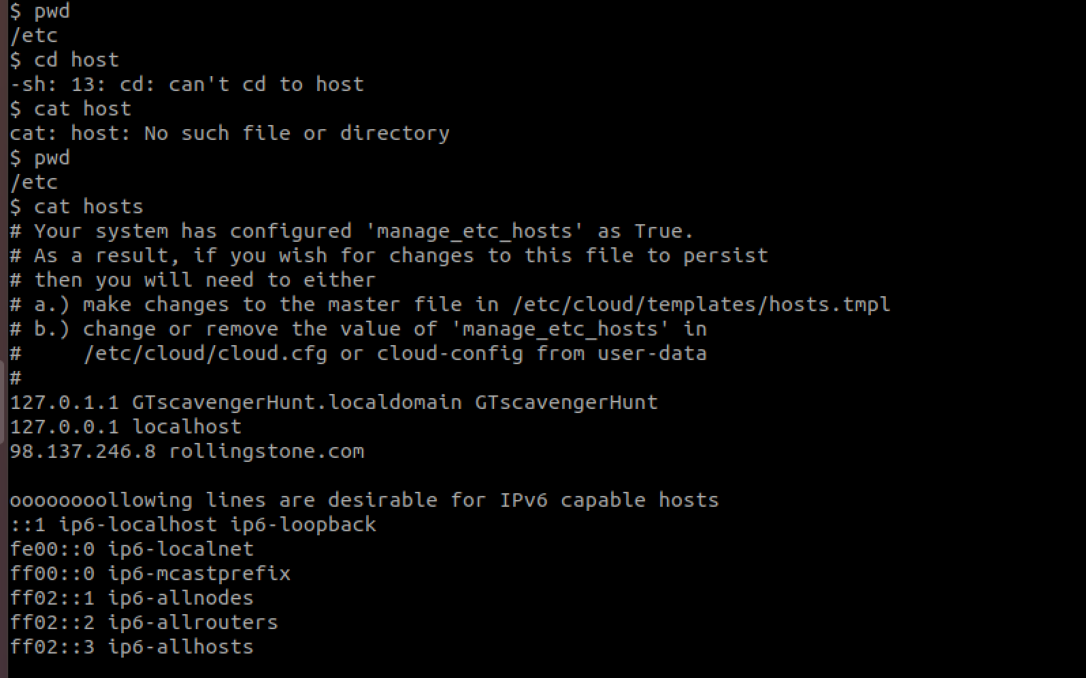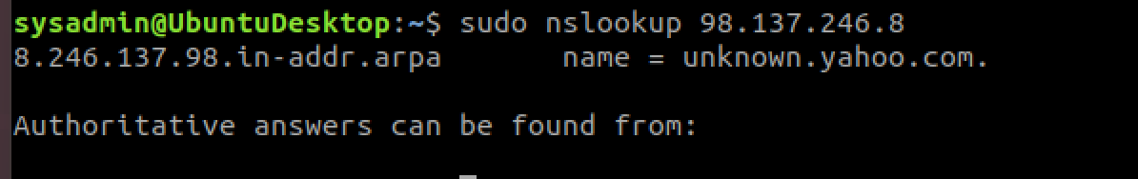
* **Summary of finding: Learned that the domain for the IP address is in yahoo.com but address is unknown.**
* **OSI Layer: Layer 7 Application**

**Phase 4:**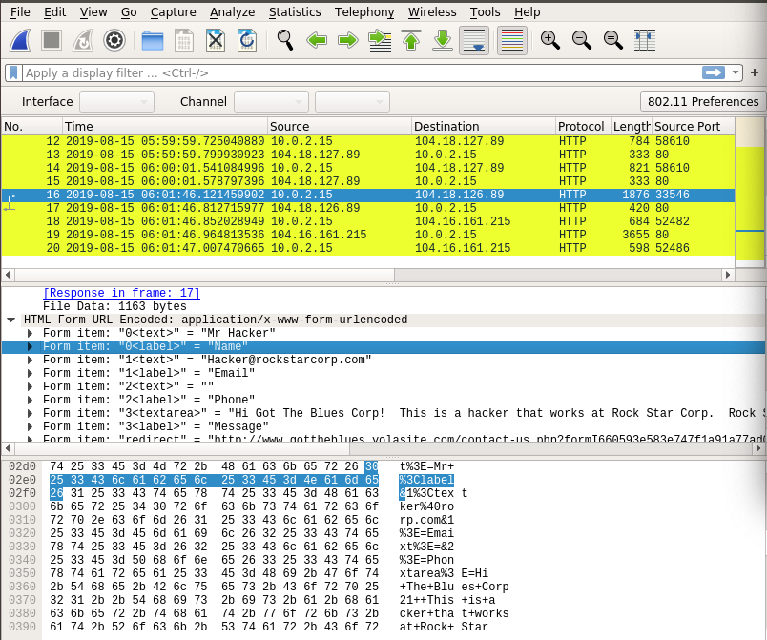

* **Summary: The hacker works for the company and has sent an email to Gottheblue and is trying to sell the usernames and passwords for 1 million dollars**
* **Mitigation: Close port 22 , investigate to find the hacker in the company, have everyone at the company change their passwords.**
* **OSI Layer: Layer 7 Application**